**PROJECT TITLE:**

# 

# CRM APPLICATIONS FOR JEWEL MANAGEMENT

**College Name:**  Bishop appasamy college of arts and science

**College Code:** BRU3GN

**(DEVELOPERS)**

**TEAM ID:**  NM2025TMID20401

**TEAM MEMBERS**

**Team Leader Name:**  KIRTHIC. V

**E-mail:** kirthicv@gmail.com

**Team Member1:** YASEEN AHAMED .Z

**E-mail:**  Zyaseenahmed@Gmail.Com

**Team Member2:**  MANOJKUMAR.A

**E-mail:**  Manojkumararanganathan@Gmail.com

**Team Member3:** YESUDAS THOMAS

**E-mail:** Yesudasthomas.S@Gmail.Com

# 1.INTRODUCTION

## 1.1 Project Overview

CRM Jewel Management is a Salesforce-based Customer Relationship Management system specifically designed for jewelry businesses. The project aims to streamline sales, inventory, customer interactions, and service management in the jewelry industry. It provides jewelers with centralized platform to manage customer data, sales orders, billing, repairs, and loyalty programs.

## 1.2 Purpose

* Maintain complete customer profiles with purchase history.
* Manage jewelry inventory including stock, categories, and availability.
* Automate billing and invoicing.
* Track repairs, services, and custom orders.
* Provide detailed sales and inventory reports for business insights.

# DEVELOPMENT PHASE

### Milestone 1: creating Developer Account

**Creating Developer Account:**

By using this URL[**- https://www.salesforce.com/form/developer-signup/?d=pb**](https://www.salesforce.com/form/developer-signup/?d=pb)

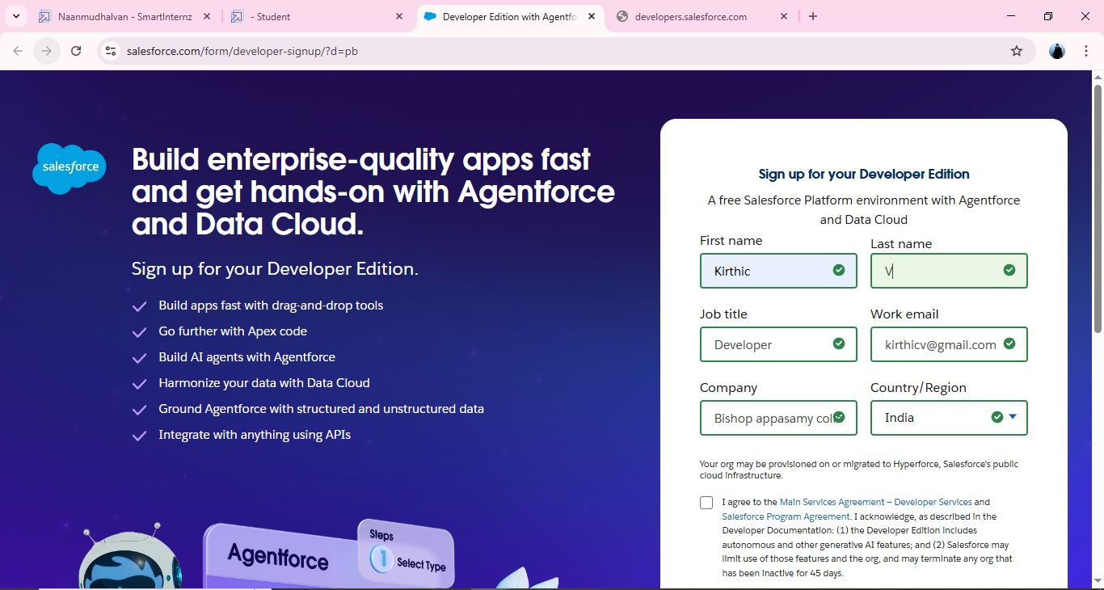

1. First name & Last name
2. Email
3. Role : Developer
4. Company : College Name
5. County : India
6. Postal Code : pin code
7. Username : should be a combination of your name and company

### Milestone 2: creating objects

### Create Object:

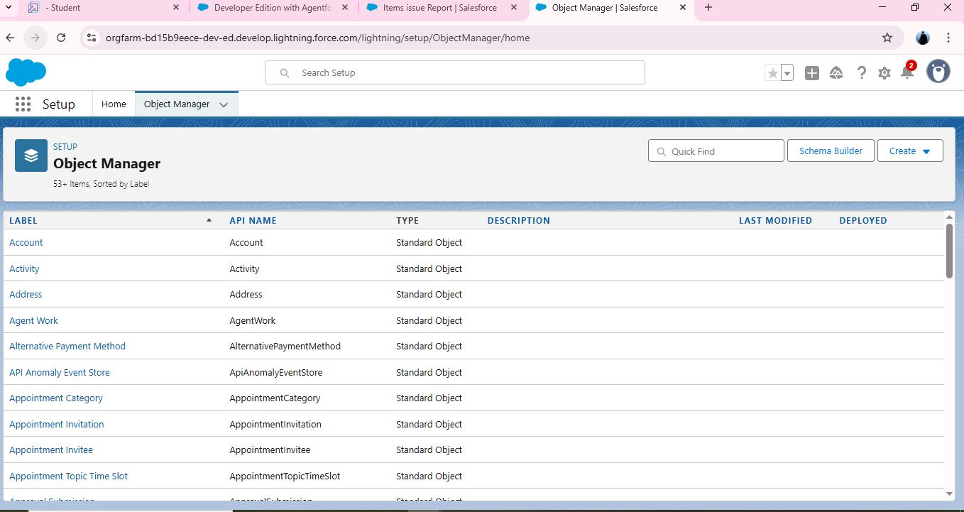

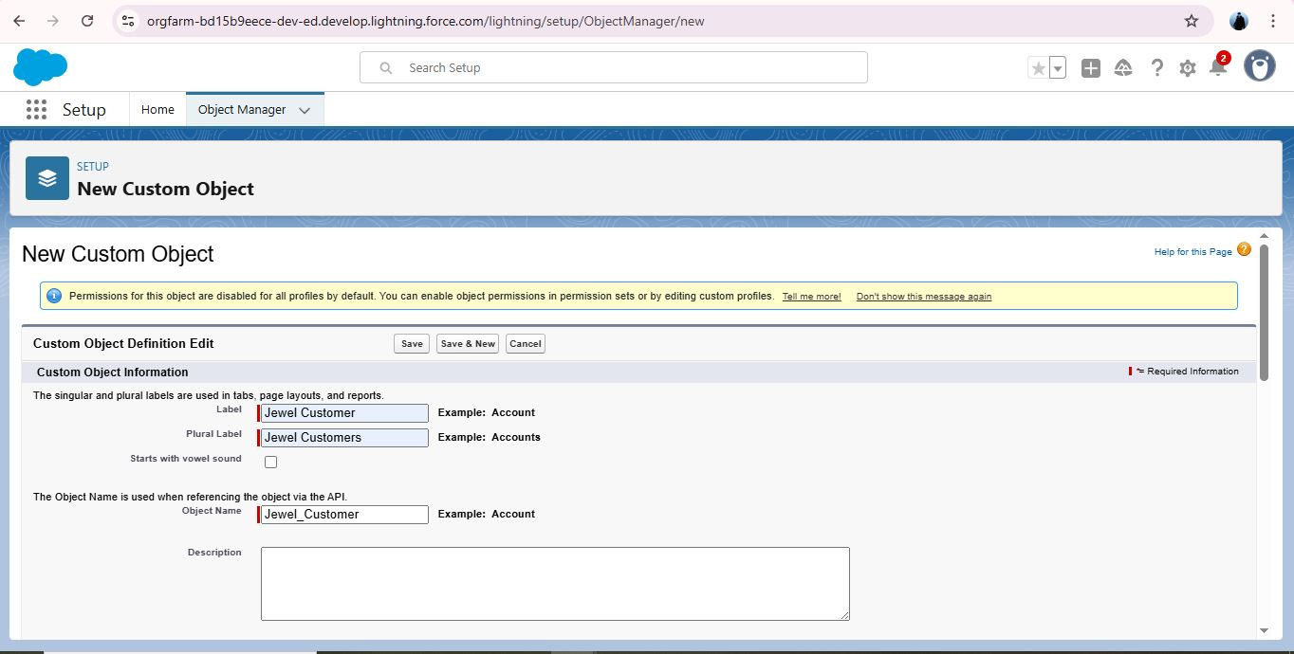

Create Jewel Customer Object

The purpose of creating a Jewel Customer custom object is to store and manage information about Customer.

To create an object:

From the setup page >> Click on Object Manager >> Click on Create >> Click on Custom Object.

1. Enter the label name: Jewel Customer
2. Plural label name : Jewel Customers
3. Enter Record Name Label and Format
4. Record Name >>
5. Customer name
6. Data Type >> Text

### Create Another Item Object

The purpose of creating a Item object is to manage the inventory of gold and silver items.

To create an object:

1. From the setup page   >> Click on Object Manager  >>  Click on Create  >>  Click on Custom Object.
2. Enter the label name >> Item
3. Plural label name >>  Items
4. Enter Record Name Label and Format

* Record Name  >>  Item Id
* Data Type >> Auto Number
* Display Format >> Item-{00}
* Starting Number >> 1

1. Click on Allow reports.
2. Allow search >> Save.

## Create 3 more objects with label names as Customer Order,Price,Billing

**(**Use “Auto Number” as a data type for Customer Order,Price,Billing).

### MILESTONE 3: CREATING TABS

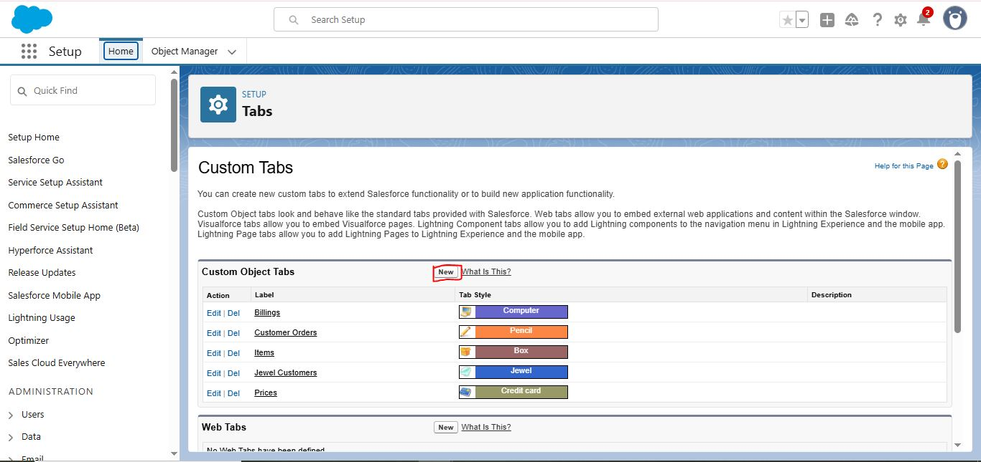

### Creating a Custom Tab

To create a Tab:(Customer)

1. Go to setup page >> type Tabs in Quick Find bar >> click on tabs >> New (under custom object tab)
2. Select Object(Jewel Customer) >> Select any tab style >> Next (Add to profiles page) keep it as default >> Next (Add to Custom App) keep it as default >> Save.



To create a Tab(Item)

Go to setup page >> type Tabs in Quick Find bar >> click on tabs >> New (under custom object tab)

Select Object(Item) >> Select the tab style >> Next (Add to profiles page) keep it as default >> Next (Add to Custom App) keep it as default >> Save.

Note: Now create tabs for Customer Order, Price, Billing objects.

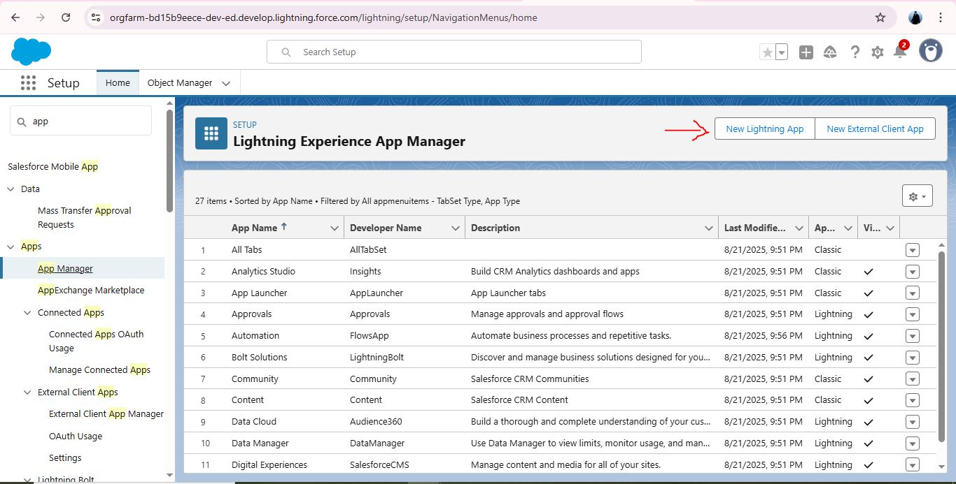

### Milestone 3: creating lighting App

### Create a Lightning App

To create a lightning app page

Go to setup page >> search “app manager” in quick find >> select “app manager” >>

1. click on New lightning App.
2. Fill the app name in app details and branding as follow  
   App Name : Jewelry Inventory System.  
   Developer Name : This will auto populated  
   Description : Elevate your look with elegance  
   Image : optional (if you want to give any image you can otherwise not mandatory)  
   Primary colour hex value : keep this default.
3. Then click Next >> (App option page)Set Navigation Style as Console Navigation >> Next.
4. (Utility Items) keep it as default >> Next.
5. To Add Navigation Items:
6. Search for the item in the (JewelCustomer,Item,CustomerOrder,Price,Billing,Reports, Dashboard) from the search bar and move it using the arrow button ? Next? Next.
7. To Add User Profiles:
8. Search profiles (System administrator) in the search bar >> click on the arrow button >> save & finish.

### Milestone 5: creating field

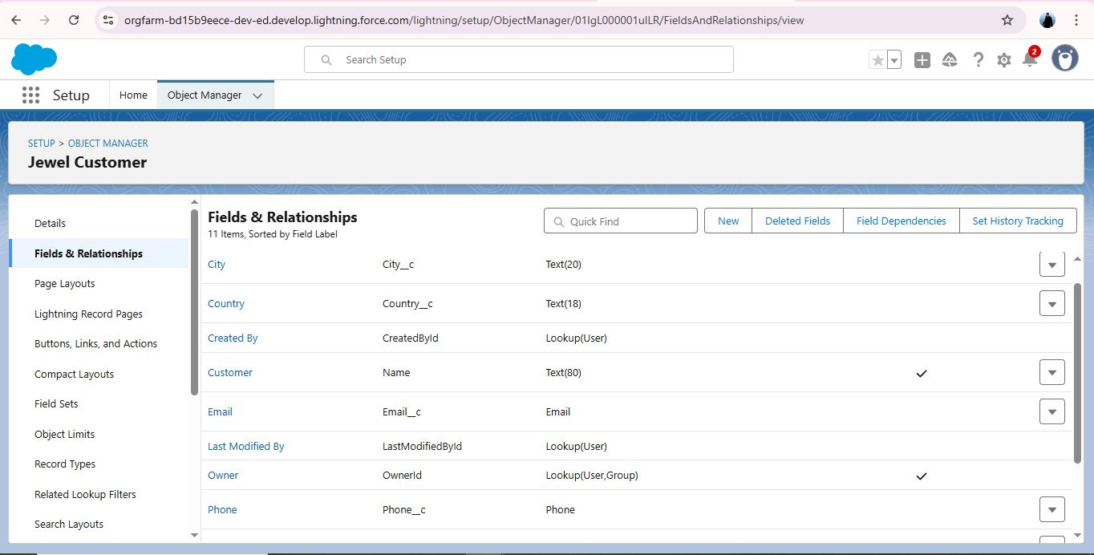

# Creating Lookup Relationship

A Lookup relationship is a type of relationship in Salesforce that connects two objects together based on a field known as the Lookup field. It establishes a relationship between a child object and a parent object, allowing the child object to reference the parent object.

To Create a relationship between Jewel Customer & Customer Order Objects.

Go to the setup page >> click on object manager >> type object name(Customer Order) in the quick find bar >> click on the object.

Click on fields & relationship >> click on New.

Select “Lookup relationship” as data type and click Next.

Select the related object “ Jewel Customer ”.

Give Field Label as “Customer” and click Next.

Next >> Next >> Save.

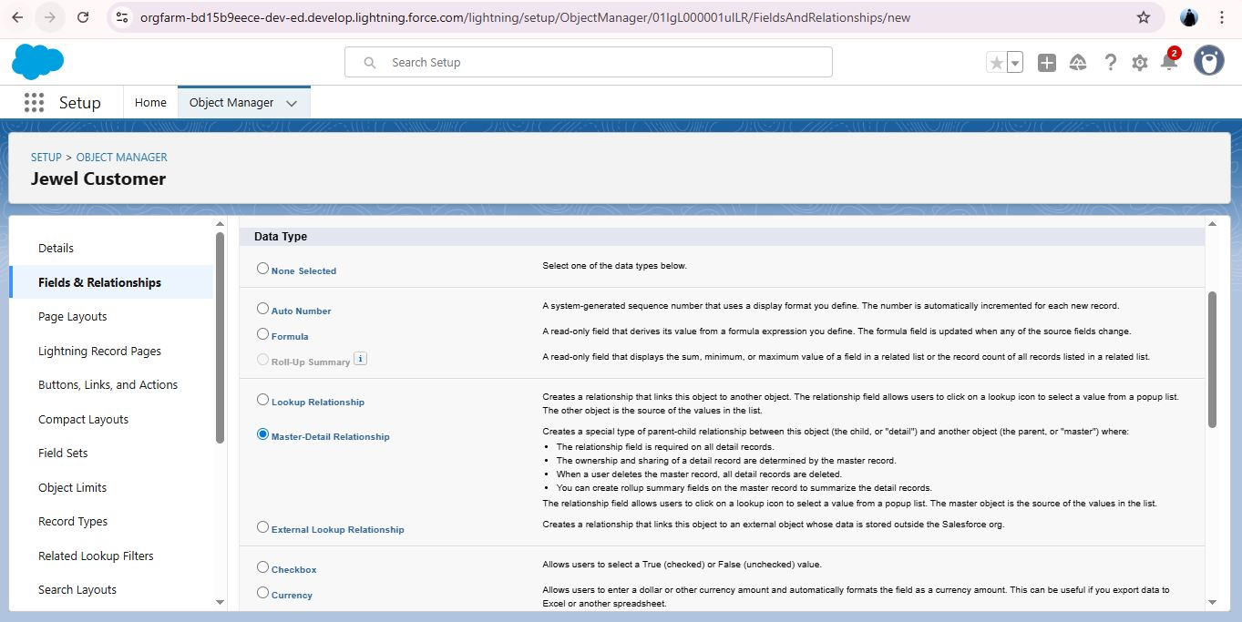

# Creating a Master-Detail Relationship

Master-detail relationship is a type of relationship between two objects where the master object controls certain behaviors and settings of the detail object. Here are a few use cases that demonstrate the use of master-detail relationships

Creating Master-Detail Relationship between Item & Customer Order Object.

To Create a Master-Detail relationship :

1.Go to the setup page >> click on object manager >> type object name(Customer Order) in the quick find bar >> click on the object.

2.Click on fields & relationships >> click on New.

3.Select “Master-Detail relationship” as data type and click Next.

4.Select the related object “ Item”.

5.Give Field Label as “Item” and click Next.

6.Next >> Next >> Save.

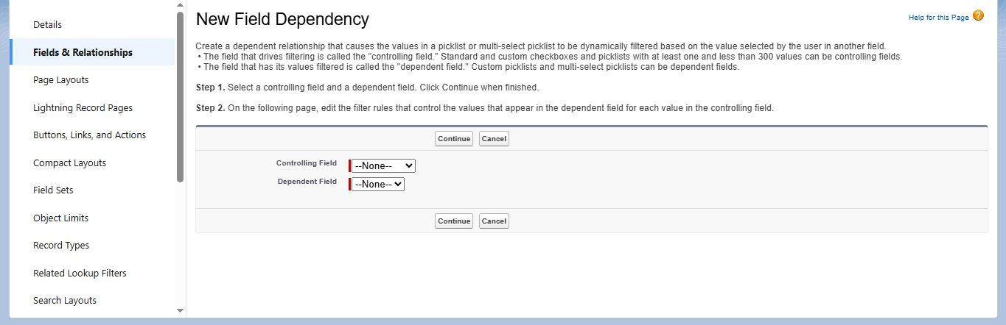

### Creating Text Field in Jewel Customer Object

To create fields in an object:

1. Go to setup >> click on Object Manager >> type object name(Jewel Customer ) in quick find bar >> click on the object.

2.Now click on “Fields & Relationships” >> New

3.Select Data type as “Text”

4.Click on Next

5.Fill the above as following:

* Field Label: City
* Length : 20
* Field Name : gets auto generated
* Click on Next >> Next >> Save and new.

# Creating the Phone field in object Jewel Customer

To create fields in an object:

Go to setup >> click on Object Manager >> type object name(Jewel Customer ) in quick find bar >> click on the object.

Now click on “Fields & Relationships” >> New

Select Data type as “Phone” and click Next.

Given the Field Label as “ Phone”.

Field Name will be auto populated, and click on Next >> Next >> Save & new.

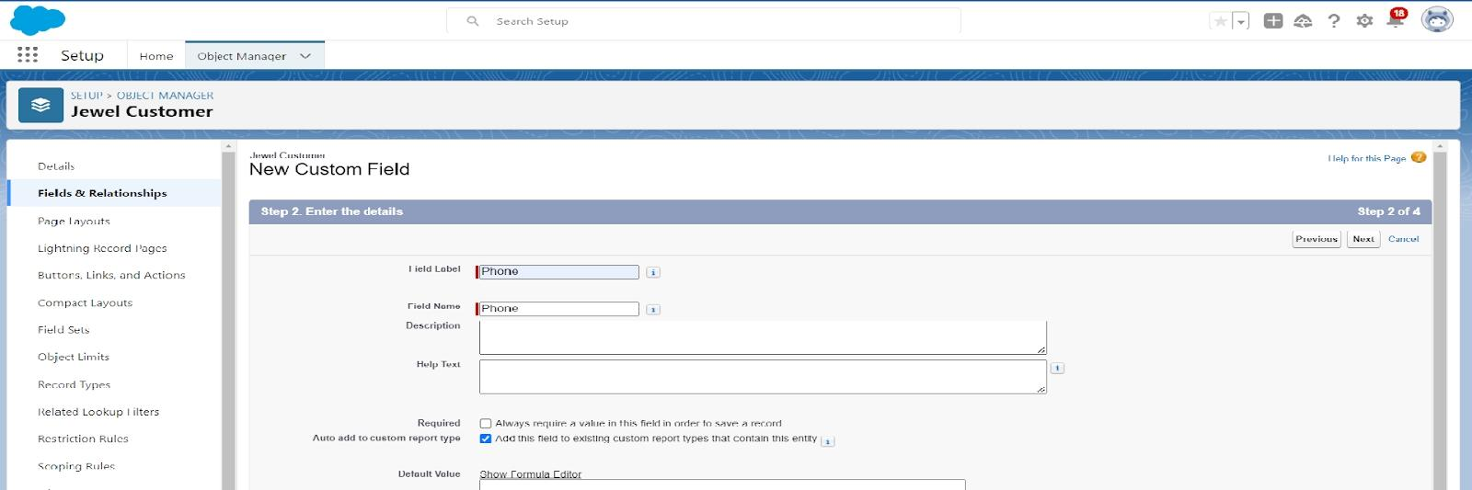

# Creating the Email field in object Jewel Customer

To create fields in an object:

Go to setup >> click on Object Manager >> type object name(Jewel Customer ) in quick find bar >> click on the object.

Now click on “Fields & Relationships” >> New

Select Data type as “Email” and click Next.

Given the Field Label as “ Email”.

Field Name will be auto populated, and click on Next >> Next >> Save.

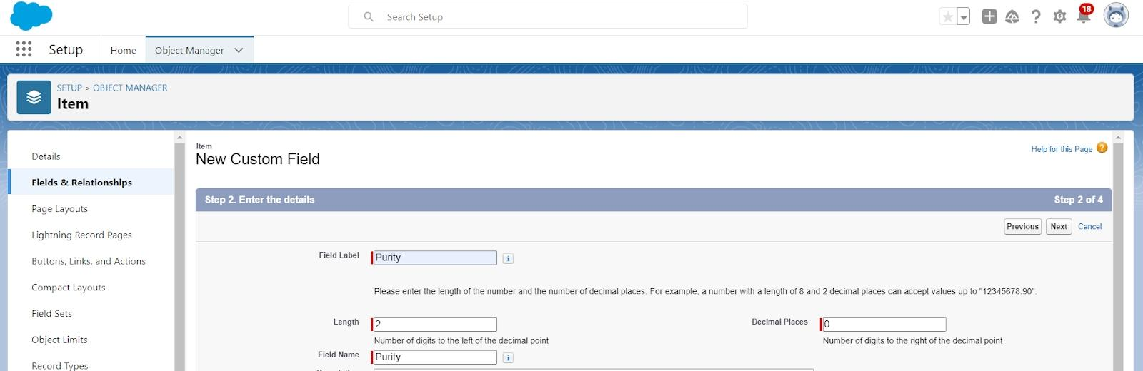

# Creating the number field in Item object

To create fields in an object:

Go to setup >> click on Object Manager >> type object name(Item) in quick find bar? Click on the object.

Now click on “Fields & Relationships” >> New

Select Data type as “Number” and click Next.

Given the Field Label as “ Purity” and length as “ 2 ”.

Field Name will be auto populated, and click on Next >> Next >> Save.



# Creating Pick list Field in Item Object

To create fields in an object:

1. Go to setup >> click on Object Manager >> type object name(Item) in quick find bar>> click on the object.
2. Now click on “Fields & Relationships” >> New.
3. Select Data type as “Pick list” and click Next.
4. Enter Field Label as “Item Type”.
5. In values select “Enter values(Gold, Silver), with each value separated by a new line" and enter values as shown below.
6. Next and next and save.

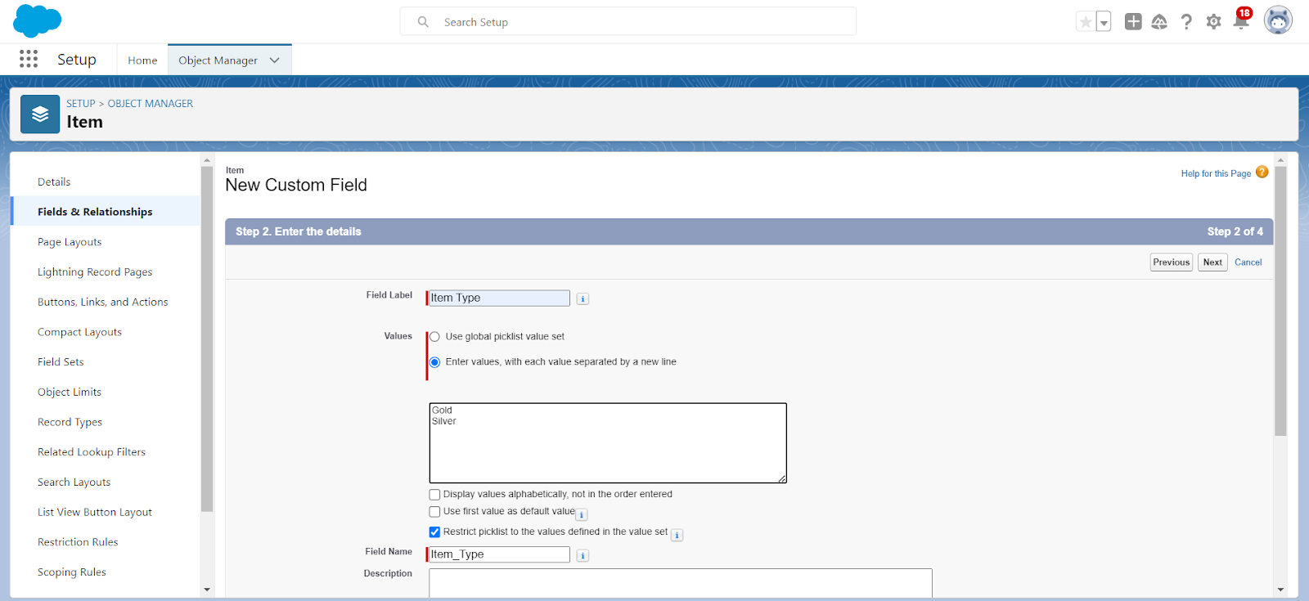

# Creating Currency Field in Price Object

To create fields in an object:

1. Go to setup >> click on Object Manager >> type object name(Price) in quick find bar >> click on the object.
2. Now click on “Fields & Relationships” >> New.
3. Select Data type as “Currency” and click Next.

4.Enter Field Label as “Gold Price” and length as “ 8”and decimal 0.Field name will be auto generated.

5.Click Next >> Next >> Next >> Save .

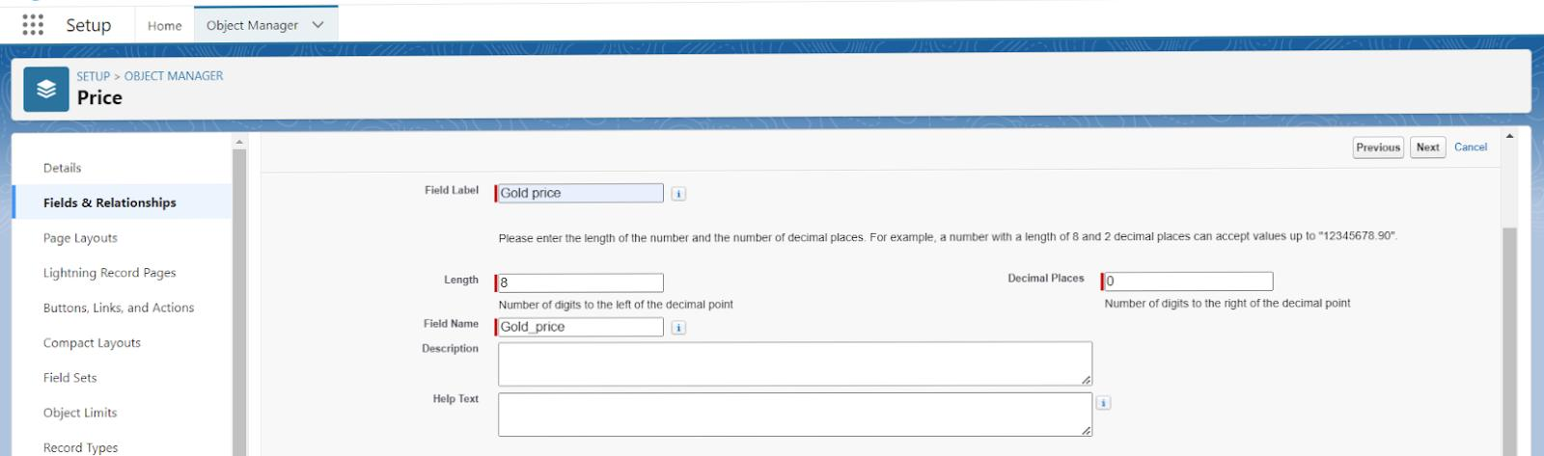

# Creating Formula Field(Cross Object) in Item Object

To create fields in an object:

(Note: Create a Lookup Relationship in Item Object to Price Object with Field Name: Prices)

1. Go to setup >> click on Object Manager >> type object name(Item) in quick find bar? Click on the object.
2. Now click on “Fields & Relationships” >> New.
3. Select Data type as “Formula” and click Next.
4. Give Field Label and Field Name as “Gold Price” and select formula return type as “Currency” and click next.
5. Under Advanced Formula write down the formula :Prices__r.Gold_price__c / 10.

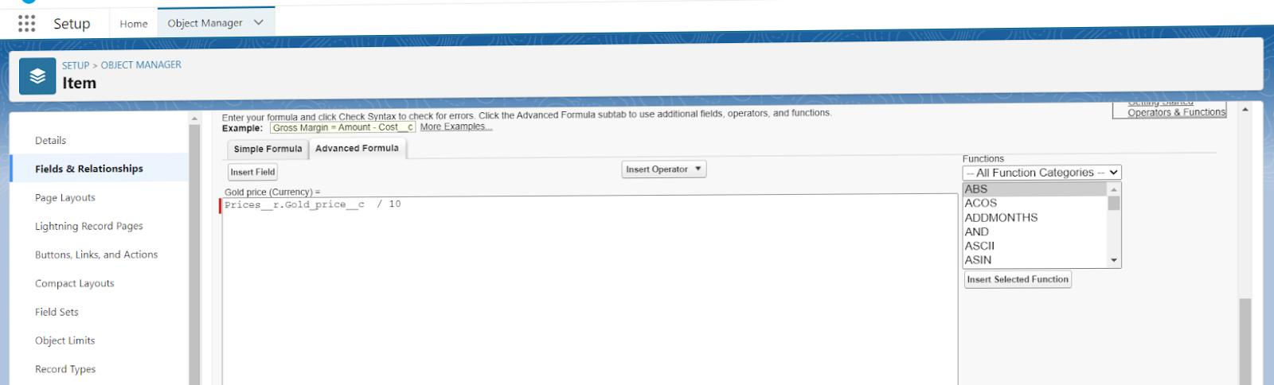

1. Click the syntax and save

# Creating Remaining Fields in Objects

* JEWEL CUSTOMER
* Prices
* Items
* Billing
* Customer order

CREATE THIS WITH THE FORMAL DATA TYPE IN RELATIONSHIP

**Object name**

Fields

1

Jewel Customer

Field Name

Data type

State

Text(20)

Street

Text(20)

Country

Text(18)

Zip/Postal code

Text(6)

2

Price

Silver Price

Currency

(Length=8,Decimal=5)

3

Item

Field Label:Customer Name

Lookup Relationship with Jewel Customer Object

Ornament

Text(20)

Weight

Number

(Length=8,Decimal=5)

Stone Weight

Number

(Length=5,Decimal=5)

Percentage

Number

(Length=2,Decimal=0)

Stone/Other Price

Currency

(Length=8,Decimal=2)

Expected Days Of Return

Picklist

1-3 Days

4-5 Days

6-7 Days

8-10 Days

Priority

Picklist

Low

Medium

High

Critical

Silver Price

Formula

(Return Type:Number)

(Decimal=3)

(Prices__r.Silver_price__c / 1000)

Purity Gold Price

Formula

(Return Type:Currency)

(Decimal=2)

((Prices__r.Gold_price__c * Purity__c ) / 24) / 10

Total Weight

Formula

(Return Type:Number)

(Decimal=3)

(Weight__c - Stone_weight__c)

Amount

Formula

(Return Type: Currency)

(Decimal=3)

IF(ISPICKVAL( Item_Type__c ,”Gold”), Total_weight__c * Purity_Gold_price__c , Total_weight__c * Silver_price__c )

KDM

Formula

(Return Type:Currency)

(Decimal=0)

(Amount__c * Percentage__c ) / 100

Making Charges

Formula

(Return Type:Currency)

(Decimal=0)

IF(ISPICKVAL( Item_Type__c ,”Gold”), Weight__c * 300 , Weight__c * 10 )

4

Customer Order

Order Status

Picklist

Started

Not Started

On Hold

Completed

Not Completed

5

Now create the remaining fields using the data types mentioned.

s.no

Object name

Fields

1

Jewel Customer

Field Name

Data type

State

Text(20)

Street

Text(20)

Country

Text(18)

Zip/Postal code

Text(6)

2:

Price

Silver Price

Currency

(Length=8,Decimal=5)

3:

Item

Field Label:Customer Name

Lookup Relationship with Jewel Customer Object

Ornament

Text(20)

Weight

Number

(Length=8,Decimal=5)

Stone Weight

Number

(Length=5,Decimal=5)

Percentage

Number

(Length=2,Decimal=0)

Stone/Other Price

Currency

(Length=8,Decimal=2)

Expected Days Of Return

Prickliest

1-3 Days

4-5 Days

6-7 Days

8-10 Days

Priority

Picklist

Low

Medium

High

Critical

Silver Price

Formula

(Return Type:Number)

(Decimal=3)

(Prices__r.Silver_price__c / 1000)

Purity Gold Price

Formula

(Return Type:Currency)

(Decimal=2)

((Prices__r.Gold_price__c * Purity__c ) / 24) / 10

Total Weight

Formula

(Return Type:Number)

(Decimal=3)

(Weight__c - Stone_weight__c)

Amount

Formula

(Return Type:Currency)

(Decimal=3)

IF(ISPICKVAL( Item_Type__c ,”Gold”), Total_weight__c * Purity_Gold_price__c , Total_weight__c * Silver_price__c )

KDM

Formula

(Return Type:Currency)

(Decimal=0)

(Amount__c * Percentage__c ) / 100

Making Charges

Formula

(Return Type:Currency)

(Decimal=0)

IF(ISPICKVAL( Item_Type__c ,”Gold”), Weight__c * 300 , Weight__c * 10 )

4:

Customer Order

Order Status

Picklist

Started

Not Started

On Hold

Completed

Not Completed

5.Billing

Field Label:Item

Lookup Relationship

With Item Object

Ornament

Formula

(Return Type:Text)

Item__r.Ornament__c

Stone weight

Formula

(Return Type:Number)

(Decimal=2)

Item__r.Stone_weight__c

Weight

Formula

Return Type:Number

(Decimal=2)

Item__r.Total_weight__c

Amount

Formula

(Return Type:Currency)

(Decimal=2)

Item__r.Amount__c

Gold/Silver Price

Formula

(Return Type:Currency)

(Decimal=2)

IF(ISPICKVAL( Item__r.Item_Type__c ,”Gold”), Item__r.Gold_price__c , Item__r.Silver_price__c )

KDM Charge

Formula

(Return Type:Currency)

(Decimal=0)

Item__r.KDM__c

Making Charges

Formula

(Return Type:Currency)

(Decimal=2)

Item__r.Making_Charges__c

Stones/other price

Formula

(Return Type:Currency)

(Decimal=2)

Item__r.Stone_other_price__c

Total Amount

Formula

(Return Type:Currency)

(Decimal=0)

Amount__c + KDM_Charge__c + Stone_other_price__c + Making_Charges__c

# Creating the Field Dependencies

Field Dependencies are used to create relationships between fields within an object. They allow you to control the visibility and availability of fields based on the values selected in other fields.

Go to setup >> click on Object Manager >> type object name(Item) in quick find bar >> click on the object.

Click on Fields & Relationships and click on the Priority field.

Search for Field Dependencies and click on New. Select Controlling Field as “Priority” and Depending field as “Expected Davs of Return” >> Continue.

Select the “Expected Days of Return” values of related Priority values and Click on Include Values >> Save.

# Creating the validation rule

Creating the validation rule for Postal Code field in Jewel Customer object

check whether the fields mentioned in the formula field are created or not , if not go to activity 10 and create those fields mentioned in Jewel Customer object.

Go to setup >> click on Object Manager >> type object name(Jewel Customer ) in quick find bar>> click on the object.

Click on the validation rule >> click New.

Enter the Rule name as “Postal Code “.

Insert the Error Condition Formula as : -

AND(

OR(

LEN( Zip_Postal_code__c ) <> 6, NOT(REGEX(Zip_Postal_code__c, “^[0-9]{6}$”))),

NOT(ISBLANK(Zip_Postal_code__c))

)

)

Enter the Error Message as “Must contain 6 digits”, select the Error location as Field and select the field as “Zip/Postal code”, and click Save.

NOTE:

Create One more Validation rule for Jewel Customer object.

Enter Rule name as “Validation Rule For JewelCustomerObject “.

Insert the Error Condition Formula as : -

OR( ISBLANK( City__c ) , ISBLANK( Country__c ),ISBLANK( Phone__c ),ISBLANK( State__c ),ISBLANK( Street__c ) )

Enter the Error Message as “Please fill Required fields”, select the Error location as Top of Page and click Save.

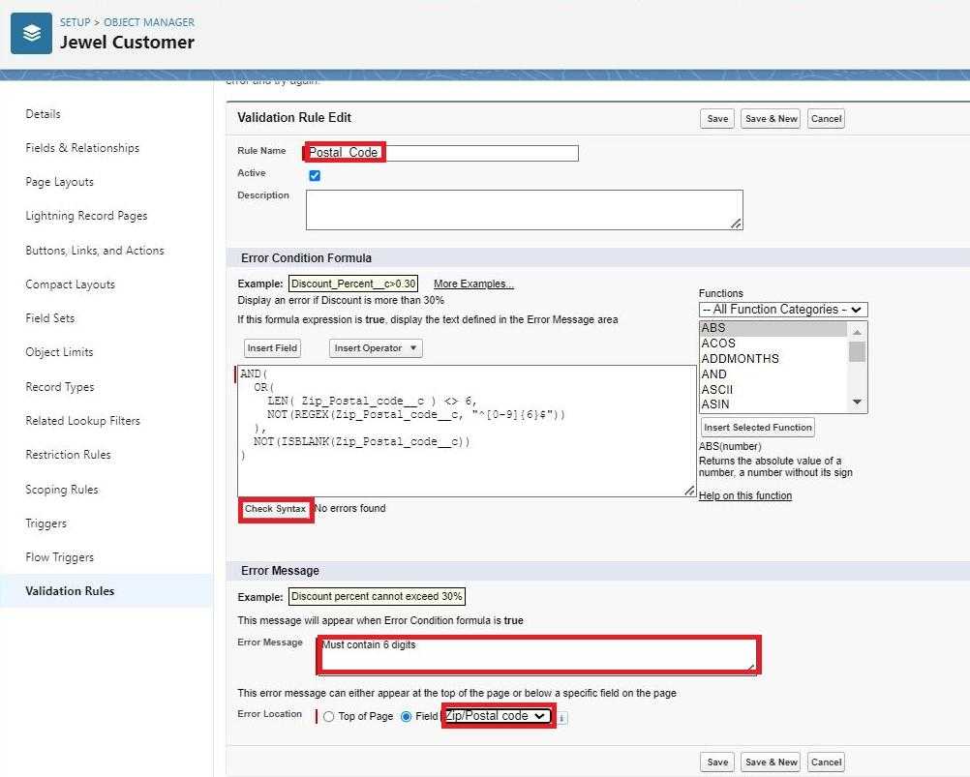

Create Validation rule for Item object.

Enter Rule name as “ValidationRule For Item“.

Insert the Error Condition Formula as : -

OR( ISBLANK( Amount__c ) , ISBLANK( Customer_Name__c ) ,ISBLANK( Gold_price__c ),ISBLANK( KDM__c ),ISBLANK( Ornament__c ),ISBLANK( Percentage__c ),ISBLANK( Making_Charges__c ),ISBLANK( Prices__c ),ISBLANK( Stone_weight__c ),ISBLANK( Silver_price__c ),ISBLANK( Stone_other_price__c ),ISBLANK( Stone_weight__c ),ISBLANK( Weight__c ))

Enter the Error Message as “Please fill Required fields”, select the Error location as Top of Page and click Save.

### Milestone 6: Create Profiles

# Gold Smith Profile

To create a new profile:

Go to setup >> type profiles in quick find box >>click on profiles ? clone the desired profile (System Administrator) >> enter profile name (Gold Smith) >> Save.

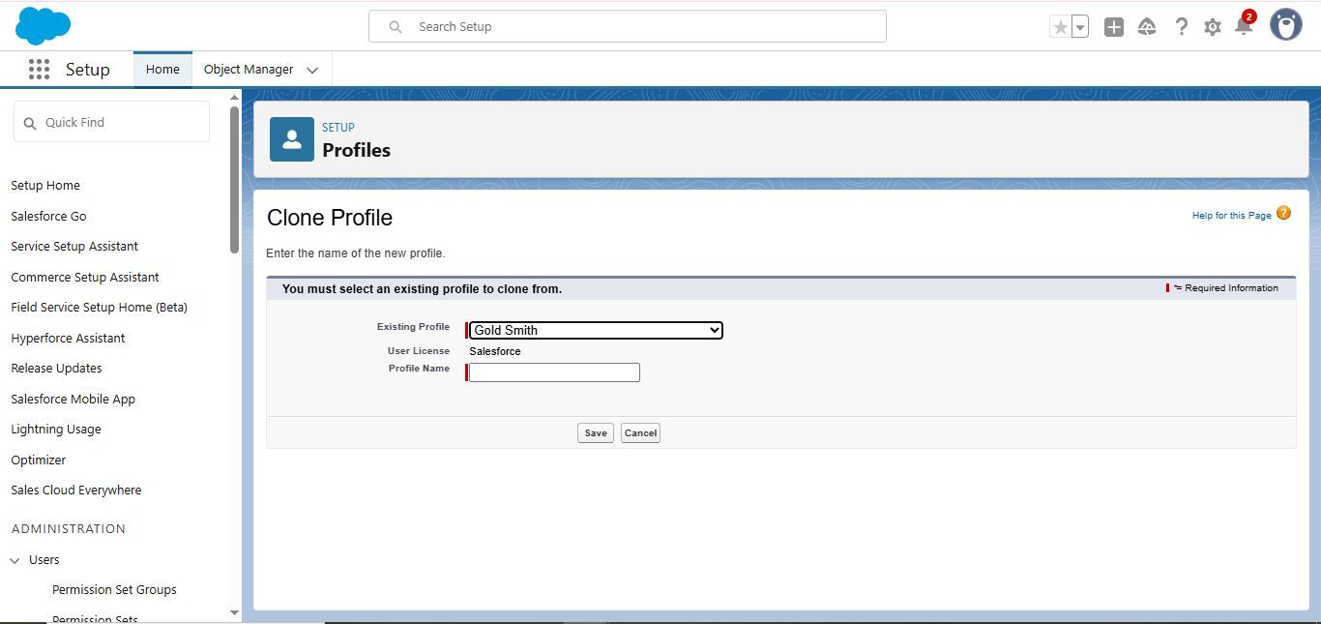

While still on the profile page, then click Edit.

Scroll down to Custom Object Permissions and Give access permissions for Jewel Customer,Item,Customer Order,Price,Billing .

Scroll down and Click on Save

# Worker Profile

Go to setup >> type profiles in quick find box >> click on profiles >> clone the desired profile (Salesforce Platform User) >> enter profile name () >> Save.

While still on the profile page, then click Edit.

Scroll down to Custom Object Permissions and Give access permissions for Items,Price and Customer Order objects.

Scroll down and Click on Save.

### Milestone 7 :Roles

# Creating Gold Smith Role

From setup ,Go to quick find >> Search for Roles >> click on set up roles.

Click on Expand All and click on add role under whom this role works.

Give Label as “Gold Smith” and Role name gets auto populated. Check to whom this role (Gold Smith) reports. Then click on Save.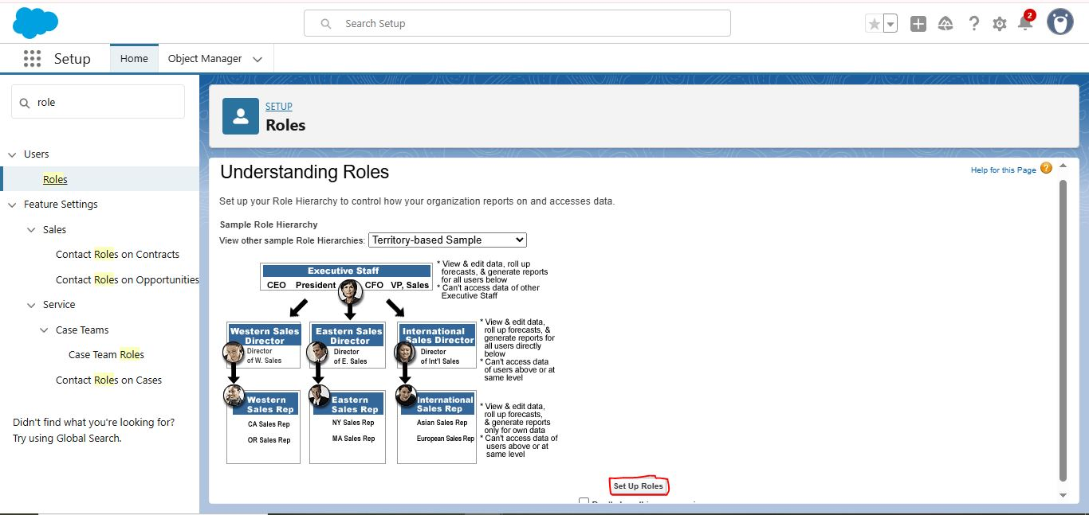

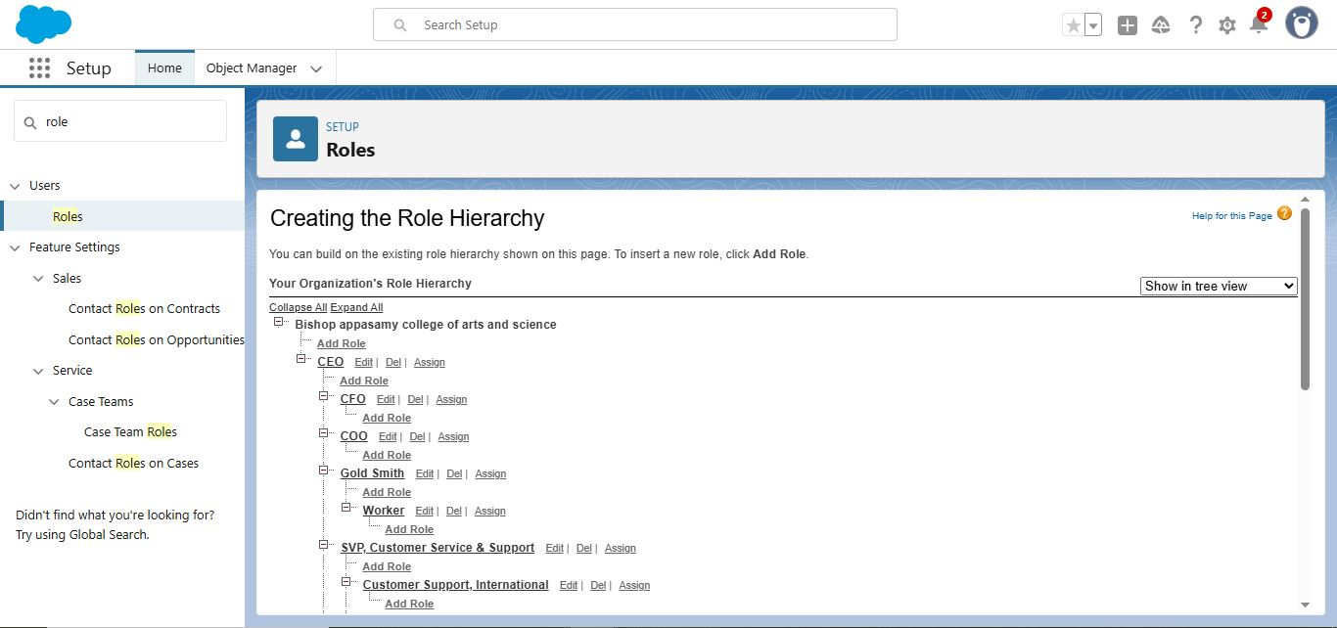

### Create one more role as Worker which reports to Gold Smith.



### Milestone8: creating users

# Users

Create User

Go to setup >> type users in quick find box >> select users >> click New user.

Fill in the fields

First Name : ***

Last Name : ***

Alias : Give a Alias Name

Email id : Give your Personal Email id

Username : Username should be in this form: [text@text.text](mailto:text@text.text)

Nick Name : Give a Nickname

Role : Gold Smith

User licence : Salesforce

Profiles : Gold Smith

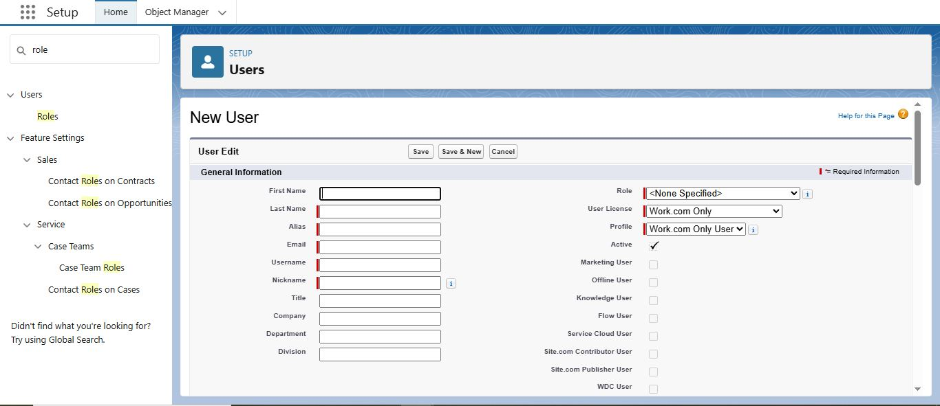

Save.

# Create Another 2User

1. Go to setup >> type users in quick find box >> select users >> click New use
2. Give the WORK and create 2 more

### Milestone 9: creating Page layout

# Page layouts

To Create a Gold Page layout

* Go to Setup >> Click on Object Manager >> Search for the object (Item) >> From drop down click on Edit
* Click on Page layout >> Click on New.
* Give Page layout Name as “Page Layout for Gold” and click on Save and New.
* Arrange the field as shown in the Information Section ,remove fields which are related to Silver and click Ok.
* Click Save.
* 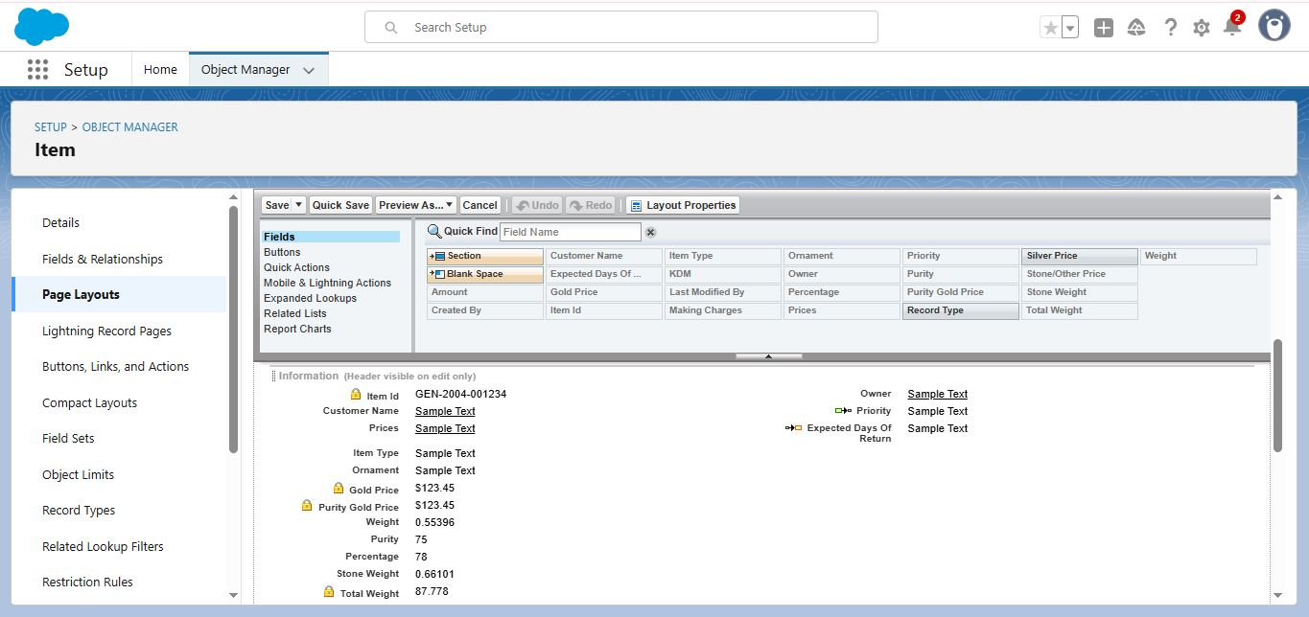Make sure your page layout looks like the picture above

# To Create a Silver Page layout

* Go to Setup >> Click on Object Manager >> Search for the object (Item) >> From drop down click on Edit.
* Click on Page layout >> Click on New.
* Give Page layout Name as “Page Layout for Silver” and click on Save.
* Arrange the field as shown in the Information Section ,remove fields which are related to Gold and click Ok.

### Milestone 10: creating Record types

# Record Types

### To create a Record Type

1. Go to setup >> click on Object Manager >> type object name(Item) in quick find bar? click on the object.
2. Click on the Record Types >> click New.

3.Select Existing Record as “Master”,Record type Label as “Gold”,Description as “Gold items information”

4.Uncheck for “Make Available”

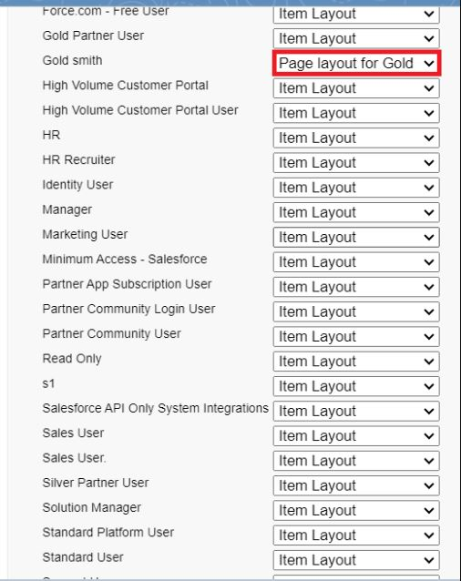5.Scroll down and check for the Gold Smith,Worker JW & System Administrator profile and click on Next

Select “Apply a different layout for each profile”, and change page layout to “Page Layout for Gold“for Gold Smith,Worker and System Administrator ? save & new.

# Create another Record Type with name “Silver” following the steps from Activity1

Use page layout for Silver.

### Milestone 11: create permission Sets

# Permission sets

### Creating permission set

A permission set is a collection of settings and permissions that give users access to various tools and functions. Permission sets extend users' functional access without changing their profiles. Users can have only one profile but, depending on the Salesforce edition, they can have multiple permission sets.

1. Go to setup >> type “permission sets” in quick search >> select permission sets >> New.
2. Enter the label name as “Per to Worker”, API will be auto populated ? save.
3. Under Apps Select object settings.
4. Click on Items object ? click on Edit ? under Item:Record Type Assignments,enable Gold,Silver ? Object permission check for read ,edit and create.
5. Click on Save.
6. After saving the permission click on the Manage assignment
7. Now click on the Add Assignment.
8. 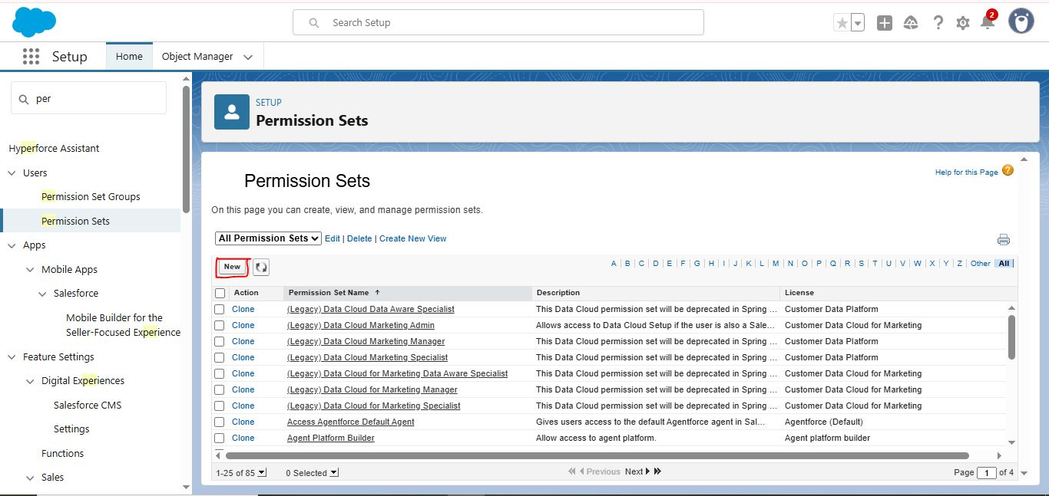Now select the users which you have created in user milestone, using Worker profile and click on Next ? Assign? Done.

### Milestone12 creating Apex Trigger

# Trigger

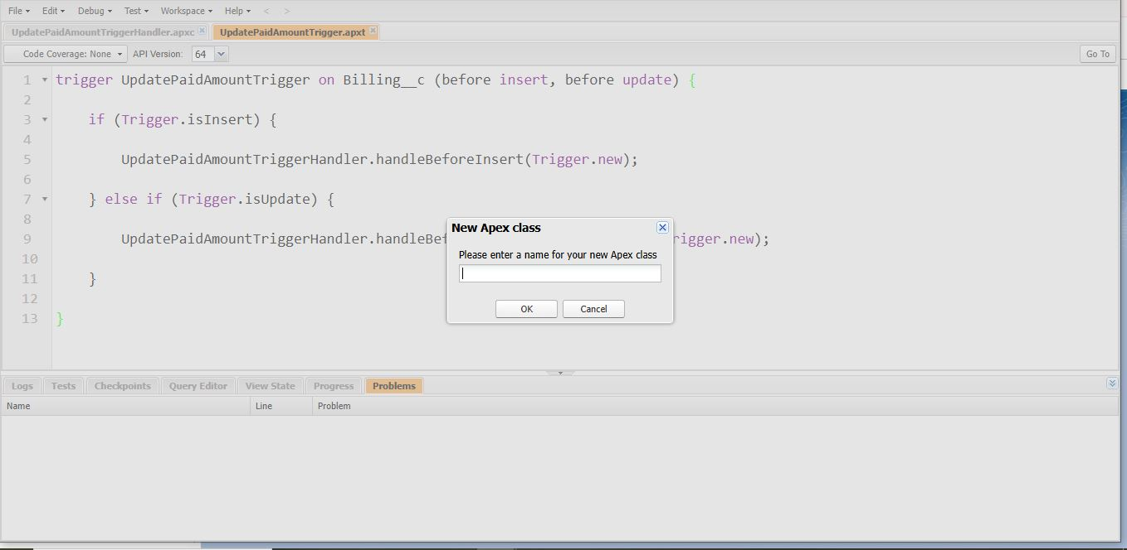use the correct coding in the apex class

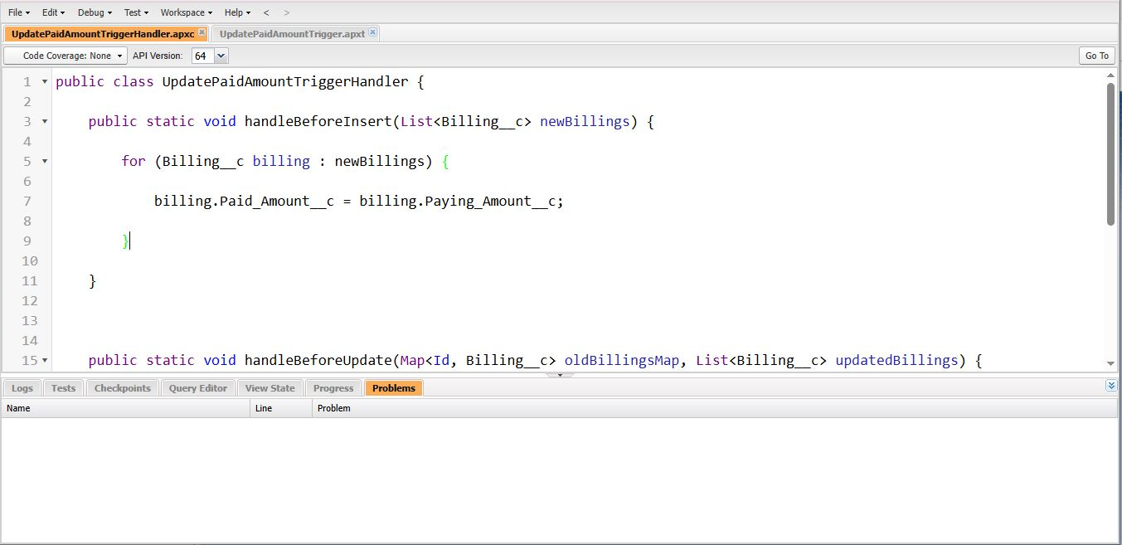

And create the apex trigger use the correct coding

### Milestone 13 : User Adoption

# User Adoption

* Create a Record (Jewel Customer)
* Click on App Launcher on the left side of the screen.
* Search Jewelry Inventory System & click on it.
* Click on Drop Down and Click on the Jewel Customer tab.
* Click New
* 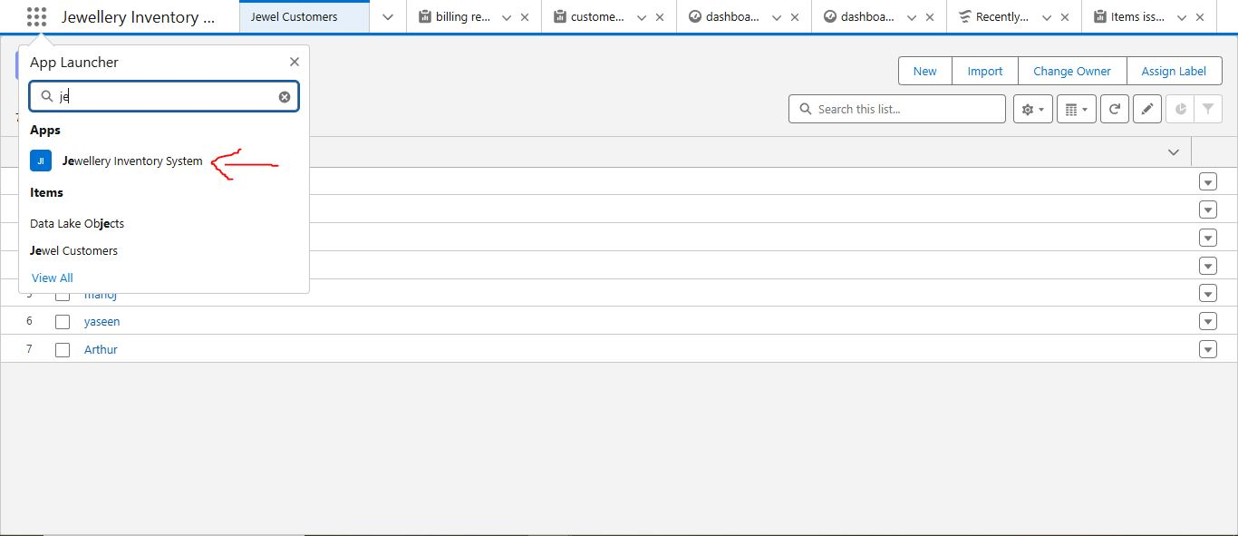Fill the Details and click on Save.

# View a Record(Jewel Customer)

* Click on App Launcher on the left side of the screen.
* Search Jewelry Inventory System & click on it.
* Click on the Jewel Customer Tab.
* Click on any record name. you can see the details of the Jewel Customer

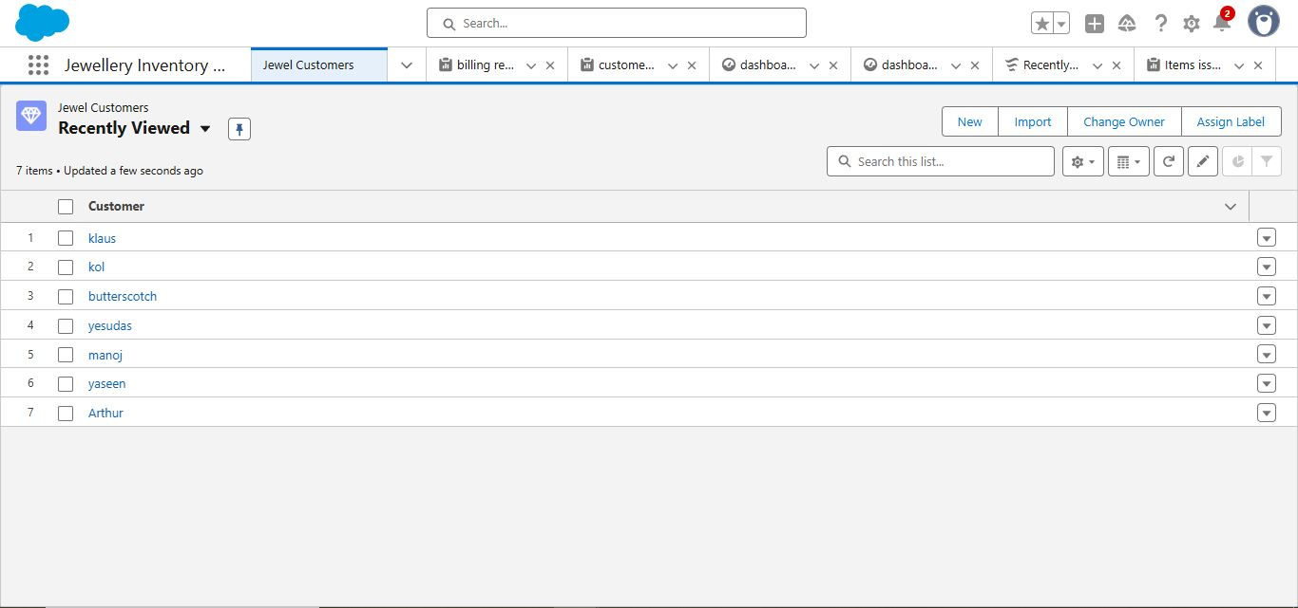

# Delete a Record(Jewel Customer)

* Click on App Launcher on the left side of the screen.
* Search Jewelry Inventory System & click on it.
* Click on the Jewel Customer Tab.
* Click on Arrow at right hand side on that Particular record.
* Click delete.
* Note:Create at least 10 records for each of the objects: Jewel Customer,Price,Item,Customer Order and Billing.

### Milestone 14: creating Reports

# Create Report

* Go to the app >> click on the reports tab
* Click New Report.
* Select report type from category or from report type panel or from search panel ? click on start report
* Customise your report
* Save or run it.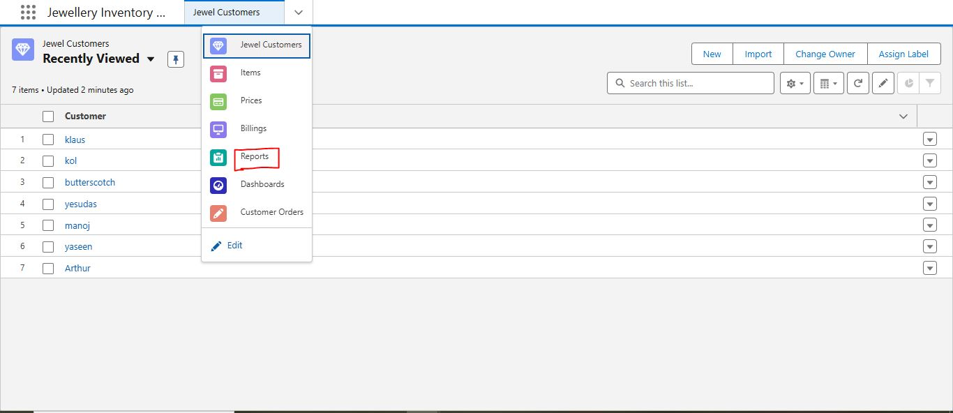

# Reports

* Create a report with report type: “Item with Billings”.
* Create a report with report type: “Billings with item and Customer order”.

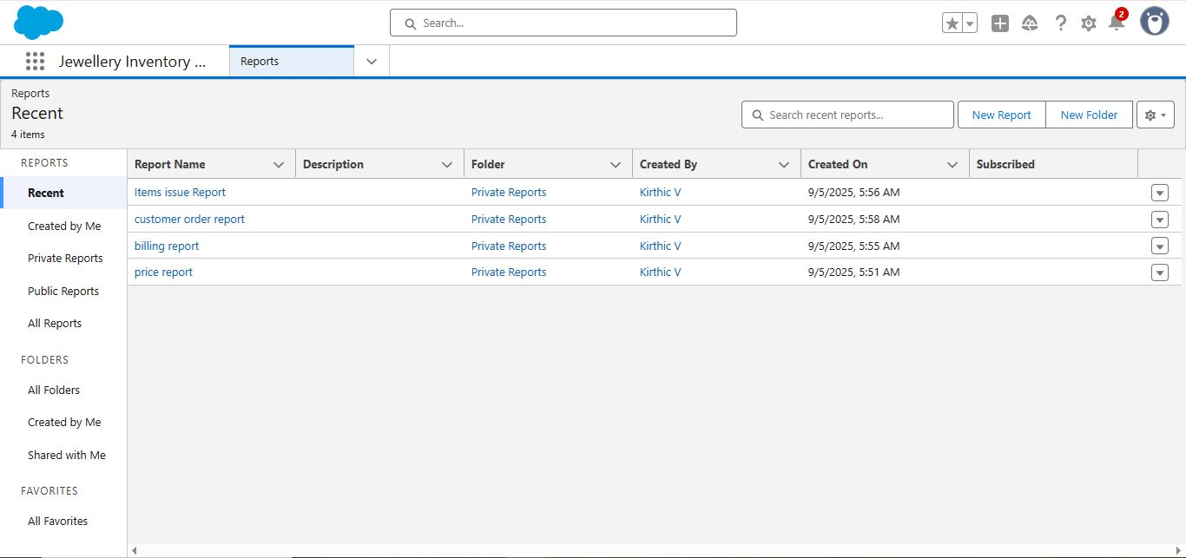

### milestone 15: creating Dashboards

# Dashboards

Create Dashboard

* Go to the app >> click on the Dashboards tabs
* Give a Name and click on Create.
* Select add component
* Select a Report and click on select.
* Click Add then click on Save and then click on Done.

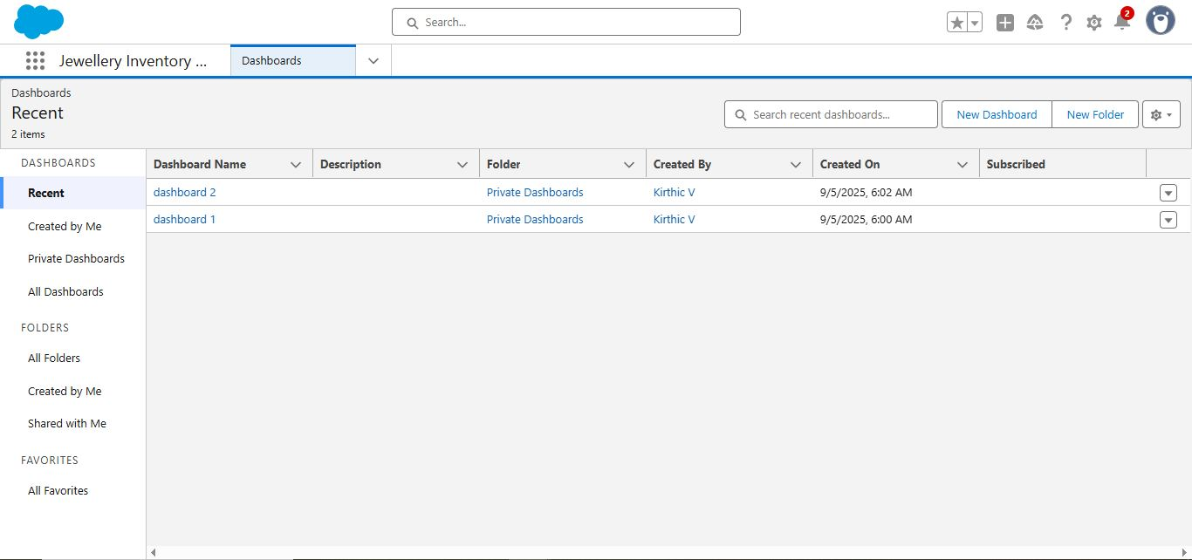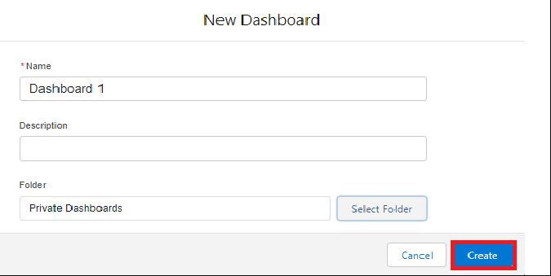

Create another Dashboard

# 

### Milestone 16 : creating Flows

# Flows

Create a Flow

1. Go to setup >> type Flow in quick find box >> Click on the Flow and Select the New Flow.
2. Select the Record-triggered flow and Click on Create.
3. 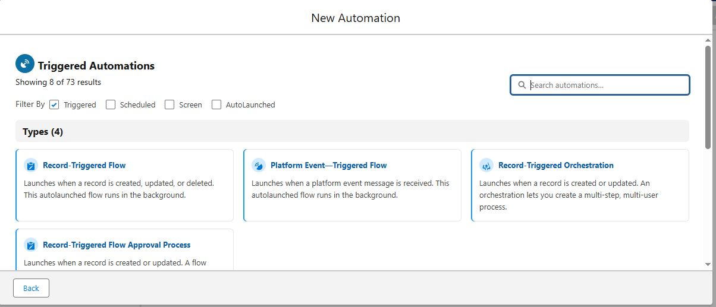Select the Object as a “Billing” in the Drop down list.
4. Select the Trigger Flow when: “A record is Created or Updated”.
5. Select the Optimise the flow for: “Actions and Related Records” and Click on Done.
6. Now change the mode form Auto-layout to free-form.
7. Now select the manger option in the toolbox, click New resource.
8. Select the resource type as text template.
9. Enter the API name as “ Email body”.
10. Ace
11. Maximize Screen
12. Create a Flow
13. Go to setup >> type Flow in quick find box >> Click on the Flow and Select the New Flow.

14.Select the Record-triggered flow and Click on Create

15.Select the Object as a “Billing” in the Drop down list

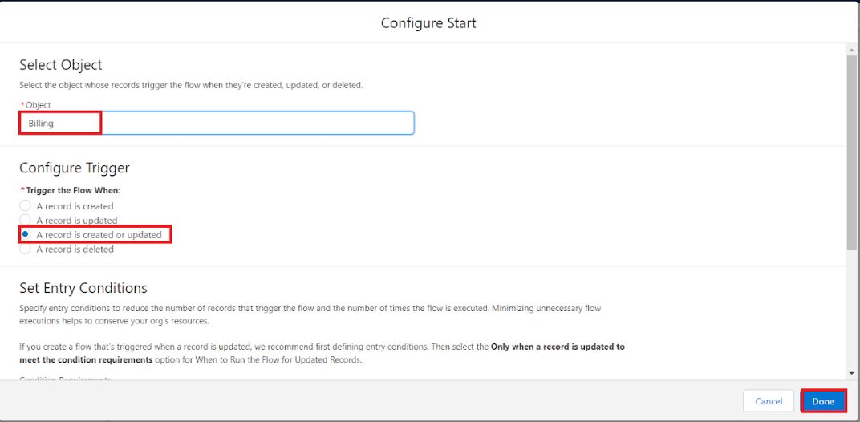

1. Select the Trigger Flow when: “A record is Created or Updated”.
2. Select the Optimise the flow for: “Actions and Related Records” and Click on Done
3. Now change the mode form Auto-layout to free-form.
4. Now select the manger option in the toolbox, click New resource.
5. Select the resource type as text template

23 Enter the API name as “ Email body

1. Change the view as Rich Text ? View to Plain Text.
2. Now click on elements, and drag the action element into the preview pane.
3. Their action bar will be opened in that search for “ send email ” and click on it.
4. Give the label name as “ notice”
5. API name will be auto populate
6. Enable the body in set input values for the selected action
7. Select the text template that was created
8. Include Recipient Address list, select the email form the record.
9. ({!$Record.Item_r.Customer_Namer.Email_c})
10. Include the subject as “Welcome to Jewelry Inventory System ”.
11. Click done.

### 

### Conclusion

The CRM application for jewel management successfully streamlines and modernizes the way jewelry businesses manage their customer relationships, inventory, and sales processes. By integrating customer data, purchase history, and personalized preferences, the system enables jewelers to deliver a more engaging and customer-focused experience. Additionally, it enhances operational efficiency through features such as order tracking, sales analysis, inventory management, and follow-up reminders. This project demonstrates how a CRM tailored to the jewelry industry not only improves customer satisfaction and loyalty but also assists business owners in making informed decisions based on real-time data. Overall, the application provides a sustainable, user-friendly, and scalable solution that bridges the gap between traditional jewelry business practices and modern digital transformation.